|  |  |
| --- | --- |
| **ENGLISH** | **TRANSLATION** |
| HEADLINE Dark horse |  |
| AUTHOR Kay Van-Petersen |  |
| INTRO The cheap money that came out of the Fed’s quantitative easing, as well as China’s massive stimulus during the financial crisis has inflated assets heavily. Global growth is decelerating, commodities have yet to find a floor, and EM assets have yet to catch up with the continuing deterioration of macro fundamentals. |  |
| PULL QUOTE “While it may seem crazy to be still bearish at one-year lows, I feel investors and traders should be looking back to 2008 levels.” |  |
| While some respected peers as well as others in the market feel that the selloff in emerging markets (is overdone and we have seen the lows, I beg to differ. I think there is a lot more downside to come, with things set to get worse before we see light at the end of the tunnel. So, while it may seem crazy to be still bearish at one-year lows, I feel investors and traders should be looking back to 2008 levels. EM equities and bonds have lagged the clear signs of stress seen in their currencies, and EM market PMIs are trending lower with their biggest trading partner, China, needing to enter a phase of quality yet slower growth, a natural evolution. |  |
| **Emerging market PMI manufacturing index in clear downtrend along with ETF (EEM)**  CHART 1  Source: Bloomberg / Saxo Bank |  |
| Although the Federal Reserve did not hike rates, it seems not only to be in search of a unicorn, but also to have taken on an additional mandate for global financial stability with oversight of the EMs and China, and the USD will still be the proverbial one-eyed emperor in the kingdom of the blind, because the rest of the world is easing. |  |
| **Malaysian ETF (EWM) multi-year bull market trend broken**  CHART 2    Source: Bloomberg / Saxo Bank |  |
| My thesis is simple: much of the cheap money that came out of the Fed’s three rounds of quantitative easing, as well as China’s massive stimulus during the global financial crisis has inflated assets heavily across the globe. Global growth is decelerating, commodities have yet to find a floor, and EM assets (bonds and equities) have yet to catch up with the continuing deterioration of macro fundamentals. |  |
| Although not all EMs are created equal, some will outperform on a relative basis: the Philippines, India and Mexico. I remain quite bearish on Malaysia – the perfect poster child for an EM meltdown – as well as Turkey, South Africa, Indonesia, and Thailand to name a few. |  |
| The best way to express views on these is through US-listed, USD-denominated exchange-traded funds and through long put options. These enable investors to limit their downside exposure, manage the volatility in their portfolios and provide a more prudent type of leverage if things go right. |  |
| The structural EM currency devaluation, continued commodity bear market conditions and the global slowdown are likely to catch up with EM equities and bonds. At the same time, I believe developed markets will outperform emerging markets over the next few quarters, perhaps even for a year down the line. So a portfolio that is structurally short EM versus structurally long developed markets on the equity side resonates well with me. As postulated many times before, I would expect more easing from the European Central Bank and the Bank of Japan, with Fed crab walking and befuddlement only increasing the pressure on the Eurozone and Japan. |  |
| Key risks to this view are: Big stimulus from China that leads to sustainable commodity demand, easing from the Fed, global growth picking up dramatically, a big USD selloff that supports commodities and emerging markets through Q4. |  |
| **From Q4 into 2016, #SaxoStrats ideas:** |  |
| **Structural shorts on EM and related global slowdown** |  |
| **Puts on emerging market ETFs:** |  |
| **EEM:** Main EM ETF for those not wanting to play through long options. One can go long EUM, which is the inverse of EEM. |  |
| **EBM**: One of the main EM USD-denominated bond ETFs. I expect a lot more downgrades. |  |
| **EWM (Malaysia):** The EM crisis poster child, Malaysia has: 1) heavy USD debt; 2) heavy foreign bond and equity ownership; 3) a position as a net exporter of commodities; 4) China as its second biggest trading partner after Singapore, which is also in a slowdown; 5) gargantuan corruption problems and political tensions that are set to accelerate; 6) mismanaged government. |  |
| **EWY (South Korea):** Rallied the most since the August selloff. Korea is in a multi-year structural competitive battle with Japan. Its biggest trading partner, China (more than 25% of exports), is now into structural yuan devaluation, and the Korean economy is highly sensitive to global growth. |  |
| **TUR (Turkey):** Turkish politics are sliding backwards and the country is now alienating its US allies. |  |
| **RSX (Russia):** Still subject to sanctions over the crisis in Ukraine. Prices of Russia’s oil exports look likely to stay low for longer, and the political and domestic environment remains dismal. |  |
| **Structural longs on developed markets and further easing** |  |
| Long South African equities and bonds as well as Japanese equities on the back of further expected easing from their respective central banks. |  |

CHART 1:

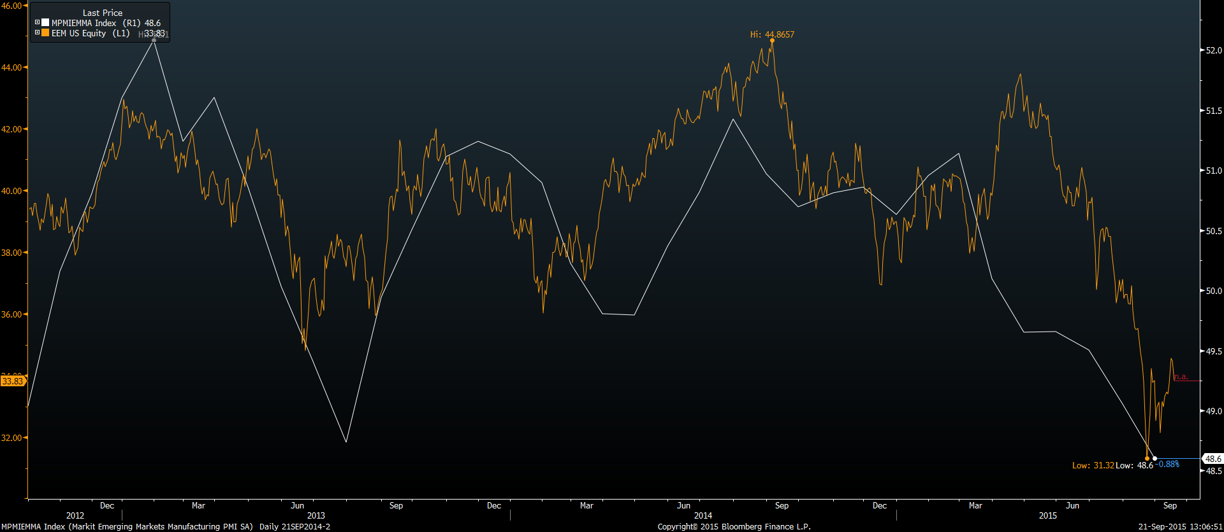

CHART 2:

